INDIA AGRICULTURAL CROP PRODUCTION ANALYSIS

(1997-2021)

*INTRODUCTION:*

* *According to The World Bank, India is a global agricultural powerhouse. It is the world's largest producer of milk, pulses, and spices, and has the world's largest cattle herd (buffaloes), as well as the largest area under wheat, rice and cotton. It is the second largest producer of rice, wheat, cotton, sugarcane, farmed fish, sheep & goat meat, fruit, vegetable*.

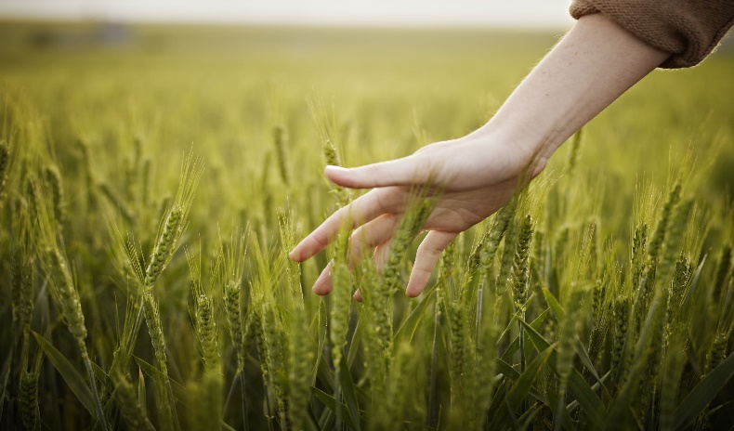

* *While agriculture’s share in India’s economy has progressively declined to less than 15% due to the high growth rates of the industrial and services sectors, the sector’s importance in India’s economic and social fabric goes well beyond this indicator. (1997 - 2021*).

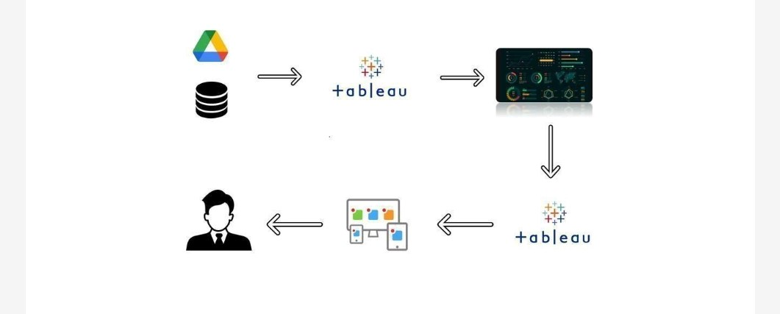

* *As per the 2014 FAO world agriculture statistics India is the world's largest producer of many fresh fruits like banana, mango, guava, papaya, lemon and vegetables like chickpea, okra and milk, major spices  like chili pepper, ginger, fibrous crops such as jute, staples such as millets and oil seed.*
* India is the second largest producer of wheat and rice, the world's major food staples.
* India is currently the world's second largest producer of several dry fruits, agriculture-based textile raw materials, roots and tuber crops, pulses, farmed fish, eggs, coconut, and numerous veg.
* India is ranked sugarcane under the world's five largest producers of over 80% of agricultural produce items, including many cash crops such as coffee and cotton, in 2010.
* India is one of the world's five largest producers of livestock and poultry, with one of the fastest growth rates, as of 2011.

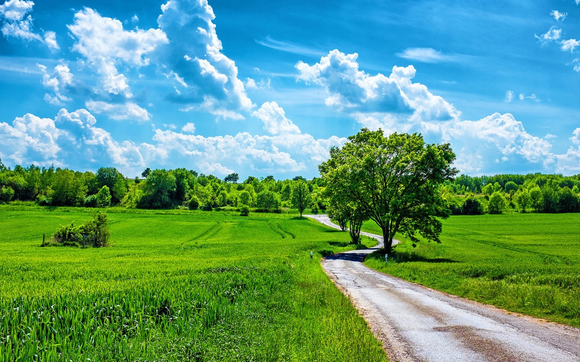

**Data of IACP**

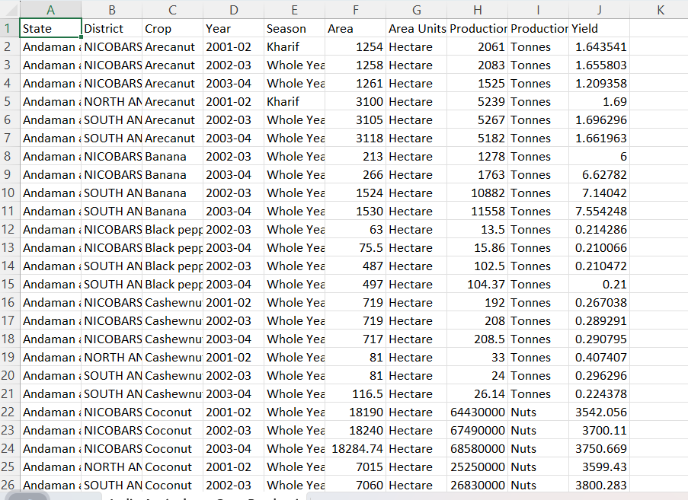

**2. PROBLEM DEFINITION & DESIGN THINKING**

***2.1EMPATHY MAP:***

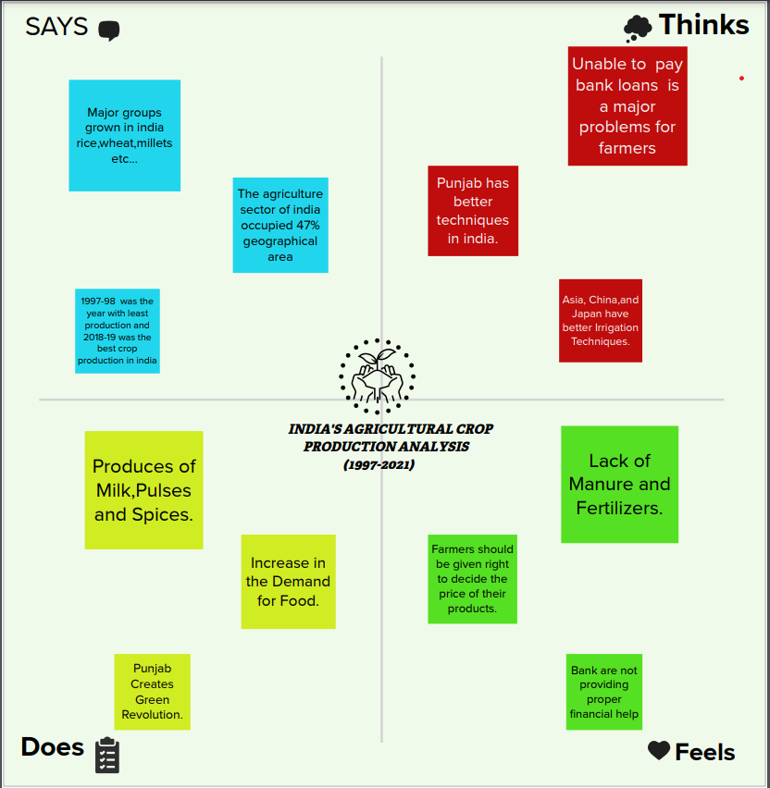

**2.2 IDEATION & BRAINSTORMING MAP**

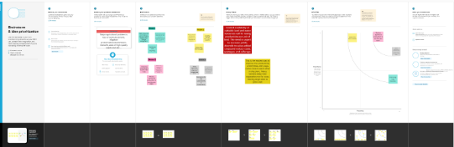

***For Empathy MAP:***

* **A*n empathy map helps to user attitudes and behaviours is an empathy map helps team align on a deep understanding of end users. The mapping process also reveals any holes in existing user data.***

***FOR BRAINSTORMING:***

* ***Brainstorming is a technique requires intensive, freewheeling discussion in which every member of the group is encouraged to think aloud and suggest as many ideas as possible based on their diverse. It is a group problem-solving method that involves the spontaneous contribution of creative ideas and solutions.***

***4. ADVANTAGES***

***The empathy map template helps you:***

* ***Common understanding and same mindset of whole team members.***
* ***It describes what users think, say, feel, do.***
* ***More organized information in easy to understand format.***
* ***The aims to capture the user’s persona based on data collected in interviews and studies.***
* ***Accelerated productivity and innovation, Increased sales, loyalty and referrals.***

***THE BRAINSTORMS & PRIORITIZATION HELPS YOU:***

* ***Create the environment. For group brainstorming, try to limit yourself to under 5 to 10 participants.***
* ***Identify the problem. Once you have gathered participants, outline the goal of the brainstorming session.***
* ***Generate ideas and share the ideas.***
* ***Narrow the list of ideas and make an action plan.***

***5. DISADVANTAGES:***

***Disadvantages of empathy map:***

* *They are designed to capture the needs and perspectives of a specific audience, but may not capture the needs and perspectives of other stakeholders.*
* *For example, an empathy map created for customers may not capture the needs and perspectives of employees or suppliers.*

*DISADVANTAGES OF BRAINSTORMING*

* ***The disadvantage of free-form brainstorming is that the less assertive or low-ranking participants may not contribute***
* ***Some participants need longer to understand the theme and can’t immediately provide ideas.***
* ***Some Participants are quieter and don’t like to speak spontaneously in group***
* ***Other Participants Speak too much***

**6.***Application:*

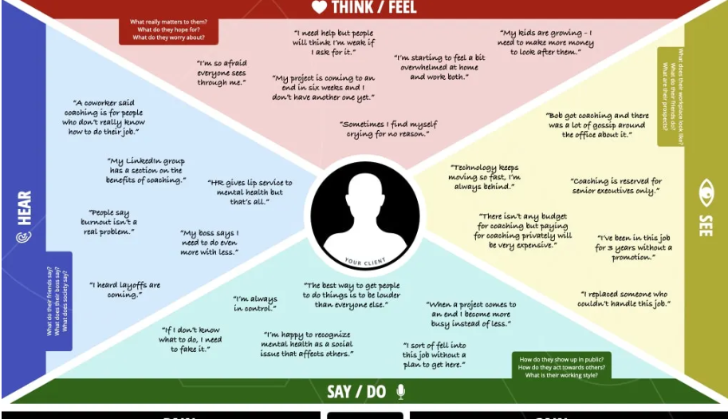

***Empathy map :***

* *An empathy map is a tool used in design thinking to build an*

Emotional representation of a user or the customer.

*It’s a versatile activity that may be used to generate new product ideas as well as better understand existing ones.*

***BRAINSTORMING:***

* *Brainstorming is a problem- solving activity where students build on or develop higher order thinking skills.*

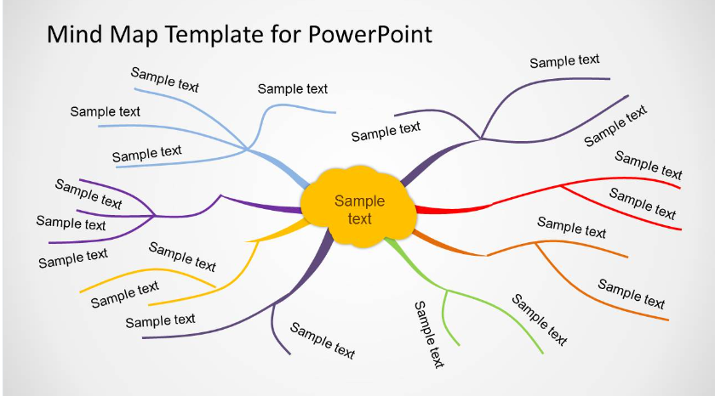

* ***E****ncourages creative thoughts.*
* ***B****rainstorming encourages students to think creatively, encouraging all the students to share their ideas, no matter how far “out there” they may seem*

***OVERVIEW***

As of 2011, India had a large and diverse agricultural sector, accounting, on average, for about 16% of GDP and 10% of export earnings. India's arable land area of 159.7 million hectares (394.6 million acres) is the second largest in the world, after the United States. Its gross irrigated crop area of 82.6 million hectares (215.6 million acres) is the largest in the world. India is among the top three global producers of many crops, including wheat, rice, pulses, cotton, peanuts, fruits and vegetables. Worldwide, as of 2011, India had the largest herds of buffalo and cattle, is the largest producer of milk and has one of the largest and fastest growing poultry industries.

PROJECT 2

INDIA AGRICULTURAL CROP PRODUCTION ANALYSI (1997-2021)

**District vs production**

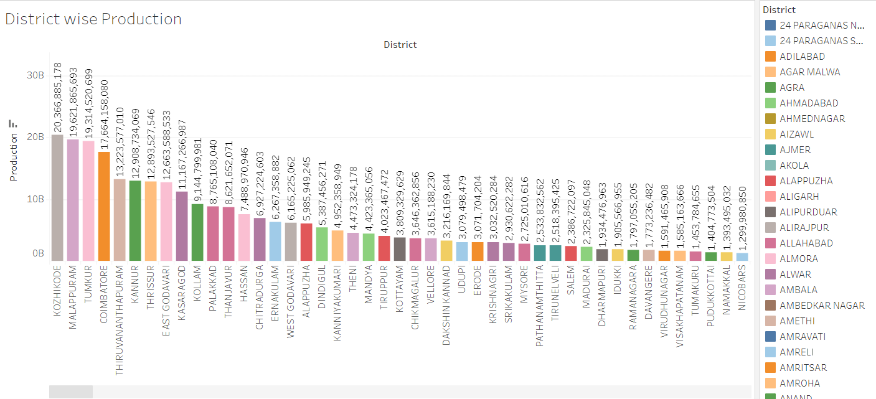 *A India agriculture the production of crop in district vice Kozhikode is high production.*

**Area vs crop**

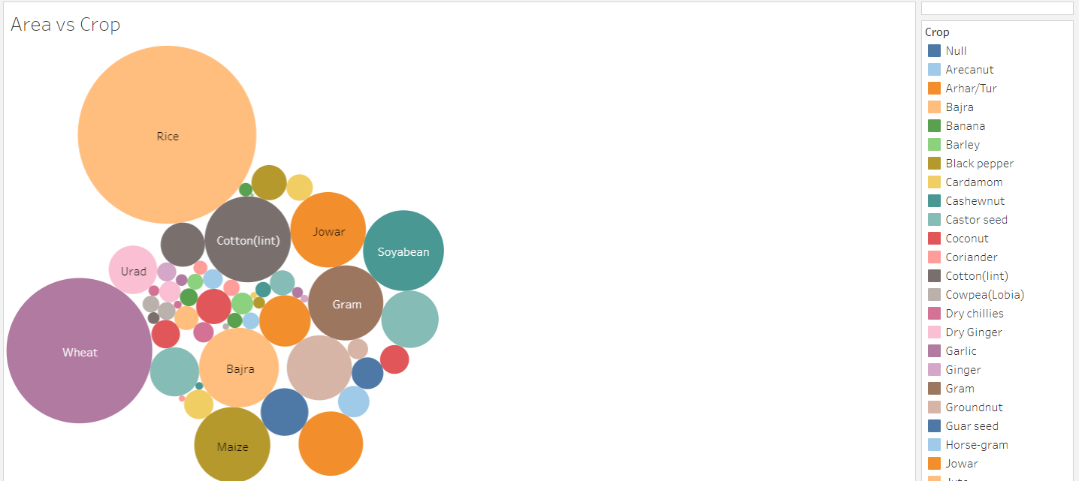

**In the agricultural area the rice is the high production crop than the other production of crops and the wheat second high production crop in area.**

**Area vs Season** 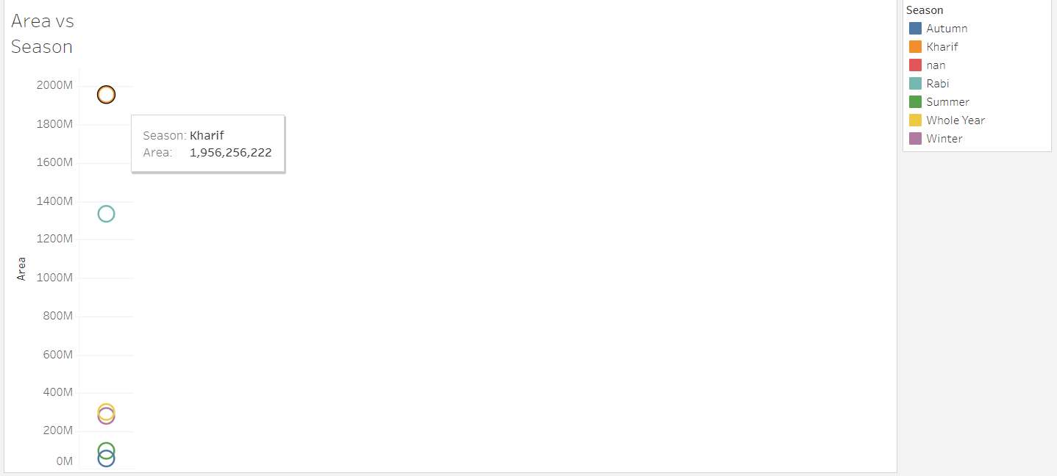

**The season of the India agricultural the kharif occupied the area is 1,956,256,222.**

**State vs Yield**

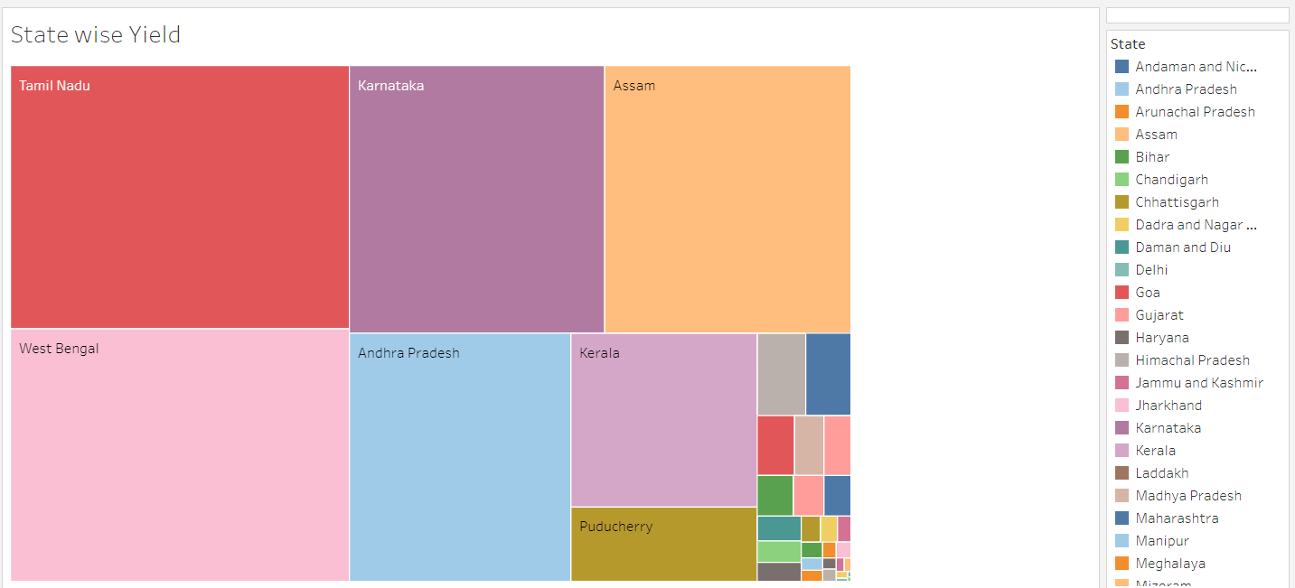

**The yield of the crop production of the state is the Tamil Nadu**

**Is the first state in India.**

**District vs yield**

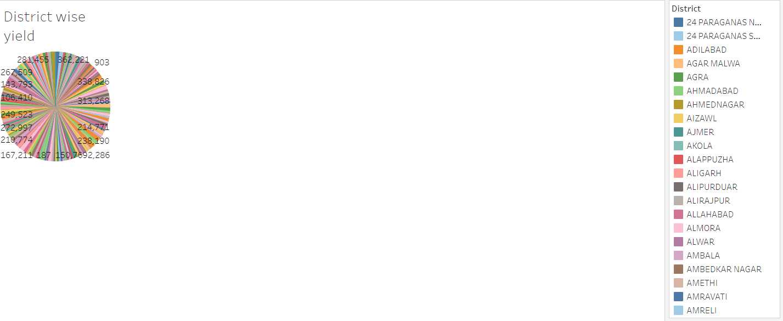

**The yield of the crop production in the district is measured in the above graph it is district vs yield.**

**Season vs year**

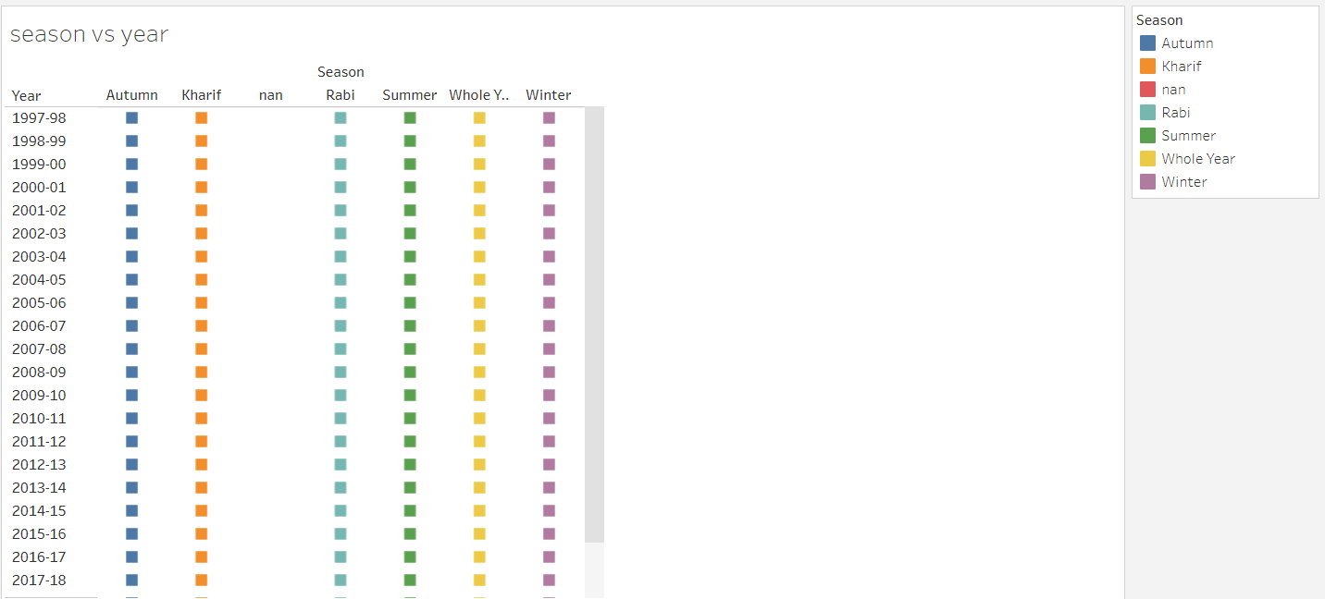

**In year 1997 to 2021 the crop production in the season are Autumn, kharif, nan, rabi , summer , the winter and the whole year.**

**State vs District**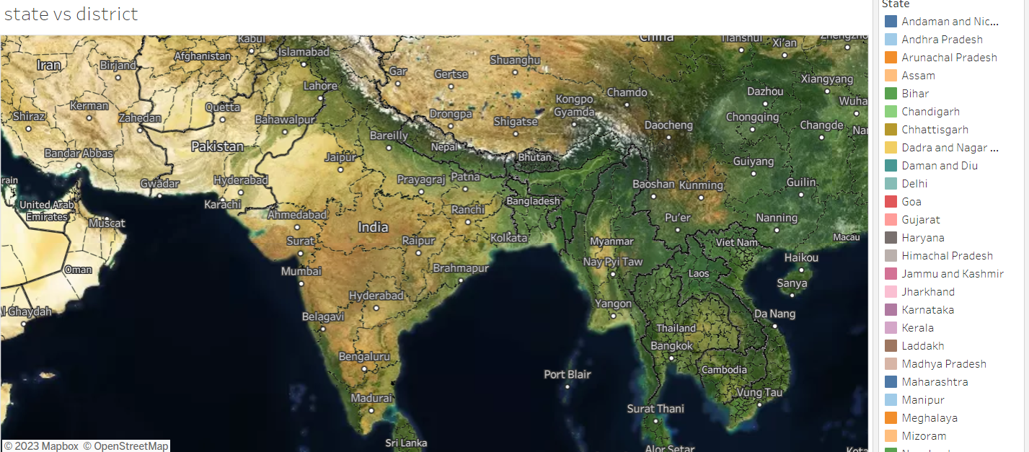

**The India agriculture crop production , the agricultural area of the district in the state.**

**DASHBOARD INDIA AGRICULTURAL CROP PRODUCTION ANALYSIS**

**(1997-2021)** 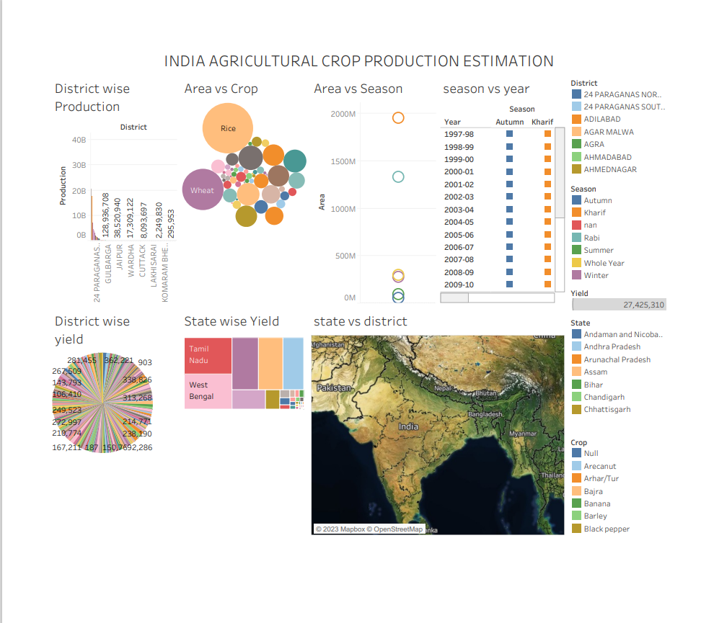

**STORY**

**INDIA AGRICULTURAL CROP PRODUCTION ANALYSIS**

**(1997-2021)**

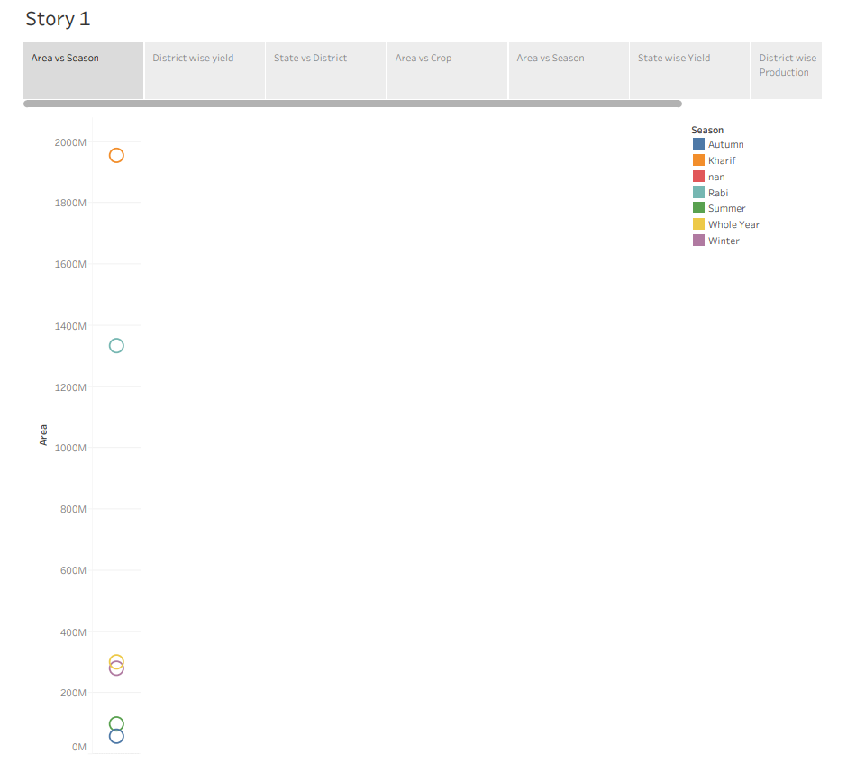

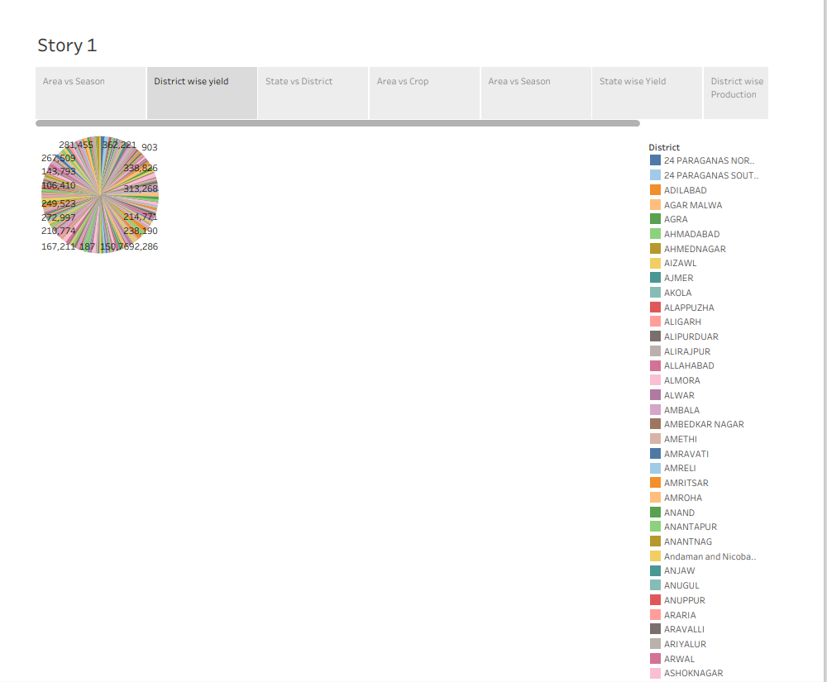

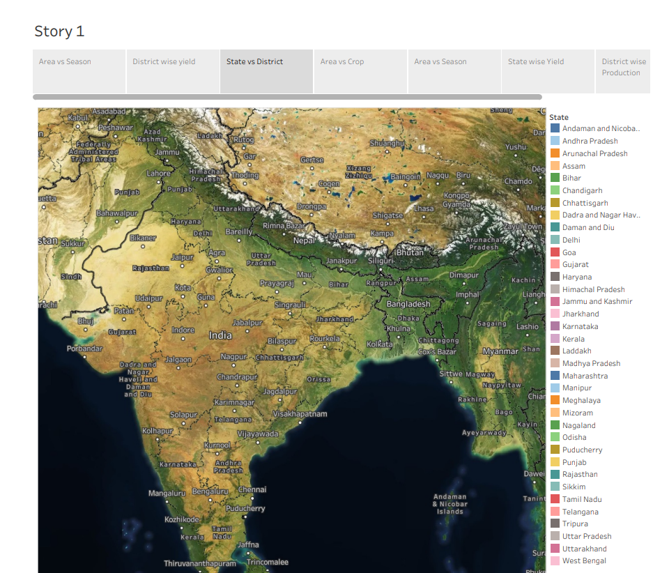

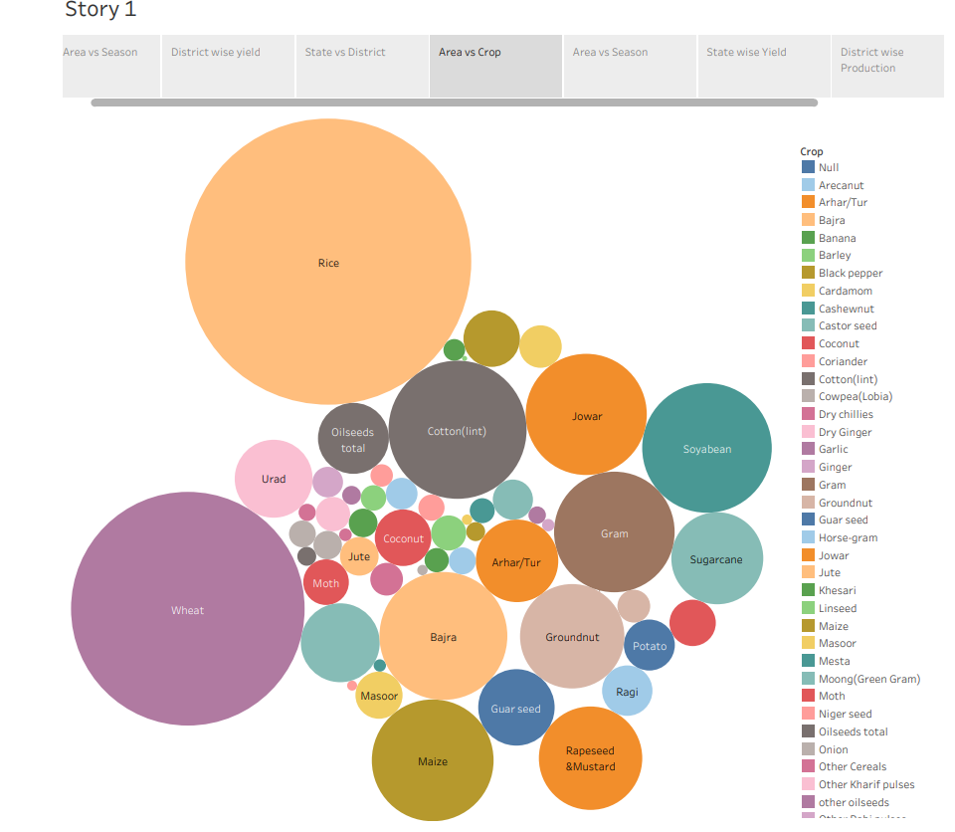

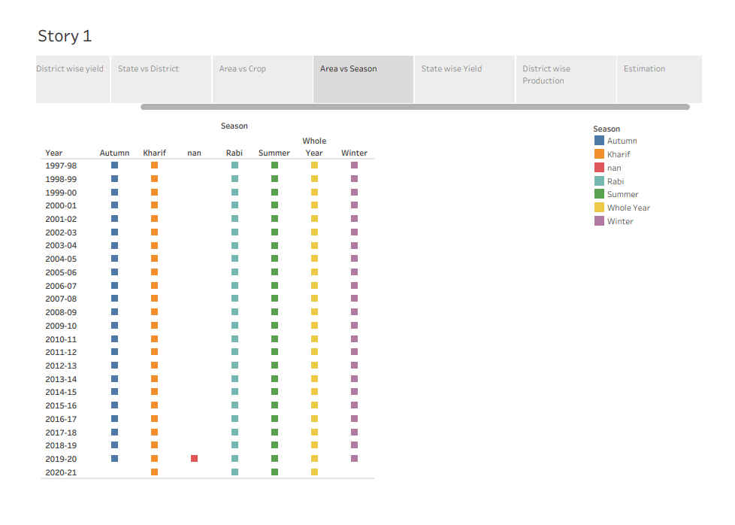

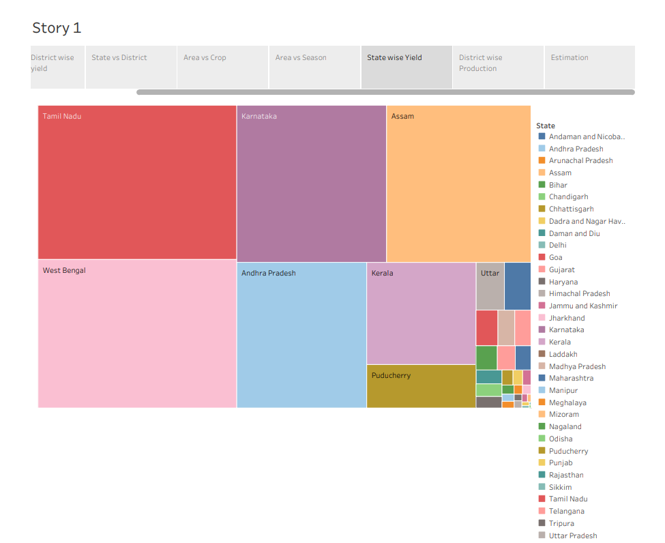

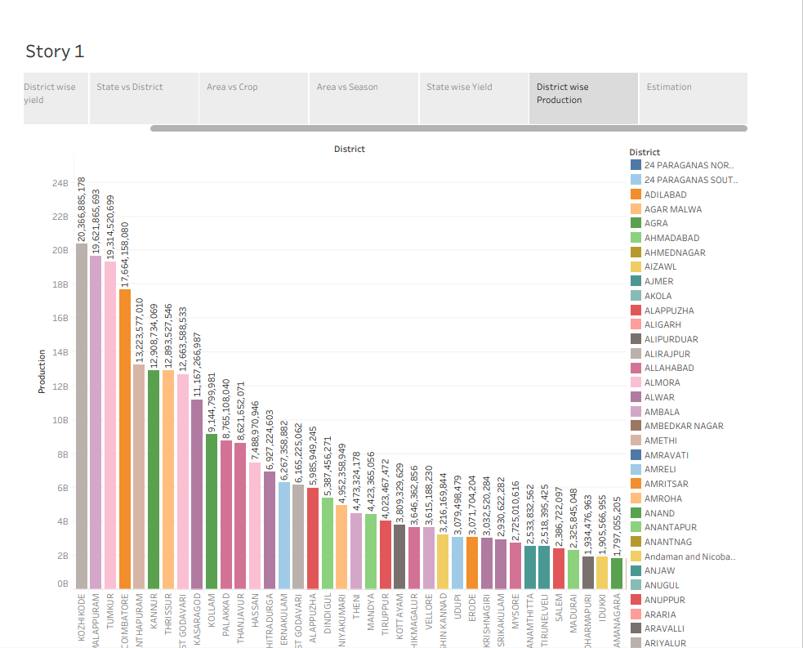

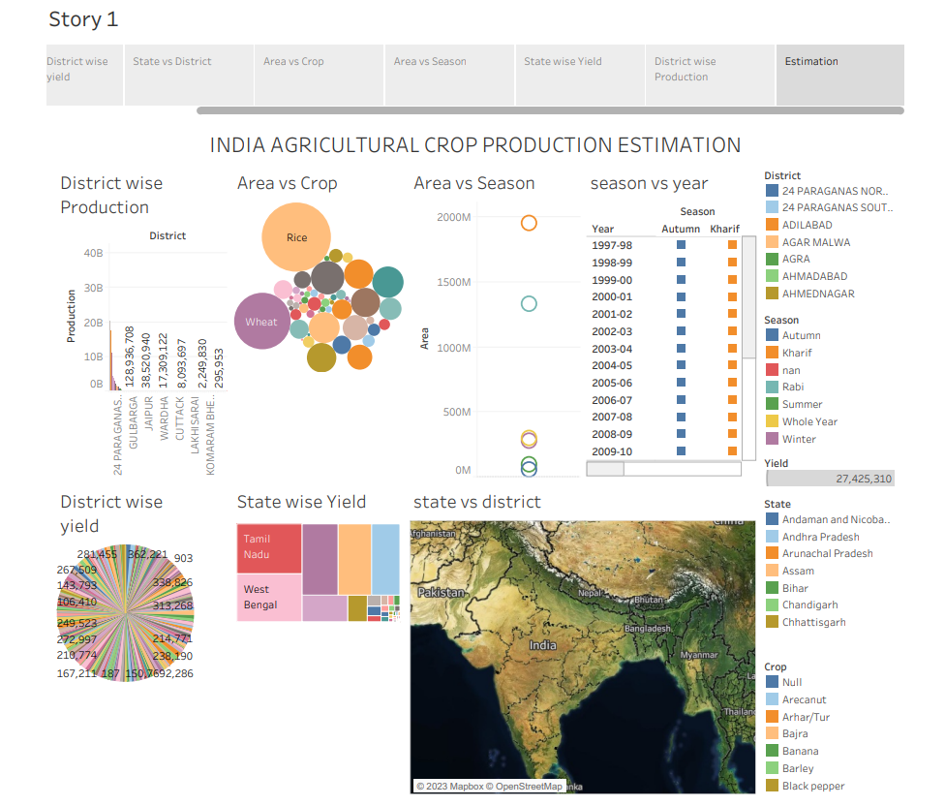

***7.CONCLUSION:***

**Hence, create a Dashboard and Story using Tableau for India Agricultural Crop Production Analysing (1997-2021).**